Project Development Phase
Performance Test

Date | 28 September 2026
Team ID | 6ab2210011b716a3e52c62c6
Project Name | Streamlining IT Procurement: Automating Standard Laptop Orders with Flow Designer
Maximum Marks | 10 Marks

Model Performance Testing:
Project team shall fill the following information in model performance testing template.
S.No. | Parameter | Screenshot / Values
1. | Data Rendered | Data generated by the flow: Catalog Task created with short description and Hardware assignment group.  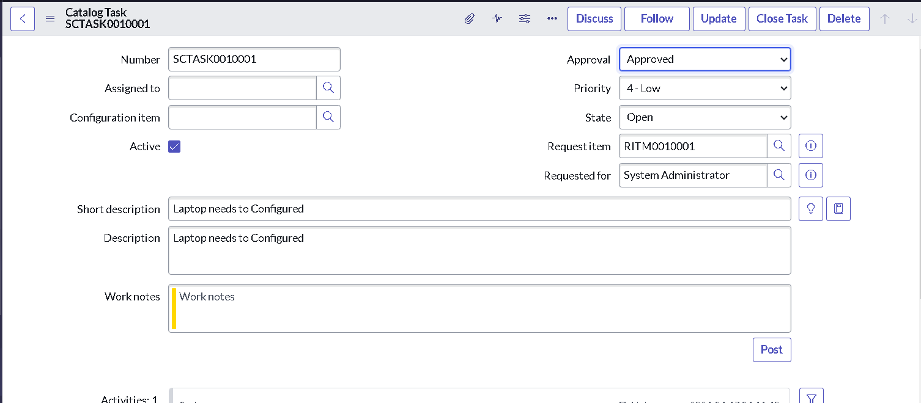  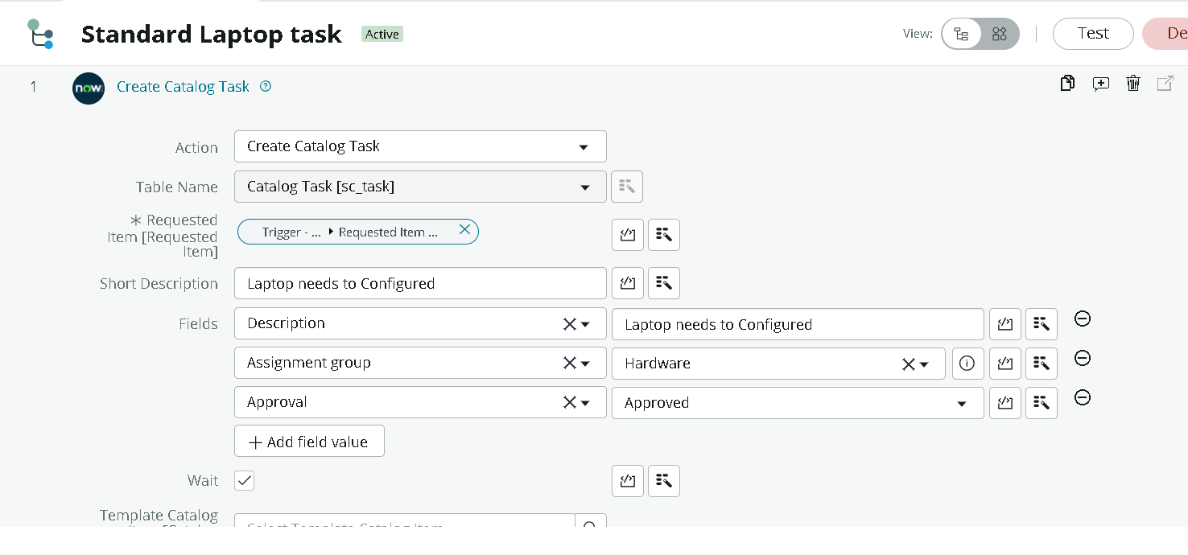
2. | Data Preprocessing | Not applicable - this project uses ServiceNow Flow Designer automation, not Tableau.
3. | Utilization of Filters | Not applicable - this project uses ServiceNow Flow Designer automation, not Tableau.
4. | Calculation fields Used | Not applicable - this project uses ServiceNow Flow Designer automation, not Tableau.
5. | Dashboard design | No of Visualizations / Graphs - 0 (Not applicable)
6 | Story Design | No of Visualizations / Graphs - 0 (Not applicable)

